AT-4/3-22(10)-guruh kursanti Boltayev Asadbek “Sun’iy intellekt asoslari” fanidan
2-Topshiriq
- Faylni ochish va unga ma’lumot yozish: output.txt faylini oching, unga “Sun’iy intellekt asoslari” matnini yozing va faylni yopishdan oldin, fayl mazmunini konsolga chiqarib bering.
#Dastur kodi
content = "sun'iy intellekt asoslari"
with open("output.txt", "w", encoding="utf-8") as f:
f.write(content)
with open("output.txt", "r", encoding="utf-8") as f:
data = f.read()
print(data)
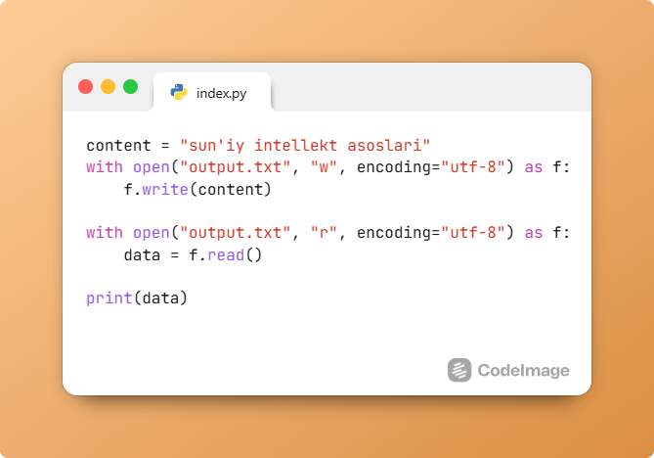
- Fayldan o'qish va qatorlarni chiqarish: input.txt faylidan birinchi qatordagi raqamni o'qing, uni integerga aylantiring va fayldan qolgan barcha qatorlarni ekranga chiqarib bering.
#Dastur kodi

with open("input.txt", "r", encoding="utf-8") as f:
lines = f.readlines()
first_number = int(lines[0].strip())
for line in lines[1:]:
print(line.strip())
